Endpoint: **http://localhost:8080/api**

Creating or adding a Book: **/books**

Using POST method:

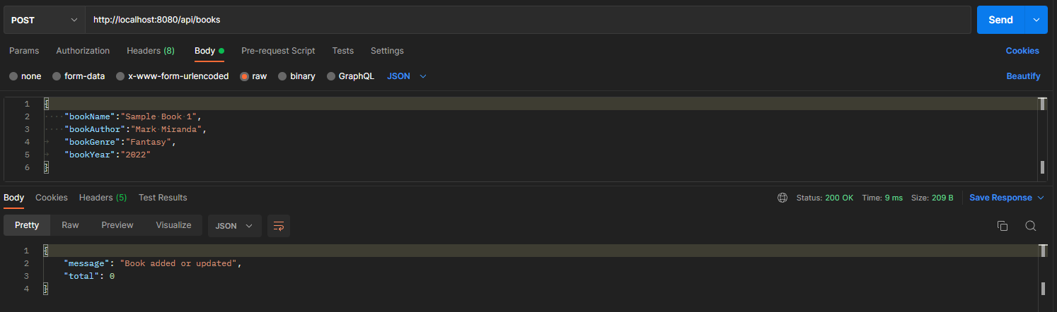

Retrieving all Books: **/books**

Using GET method:

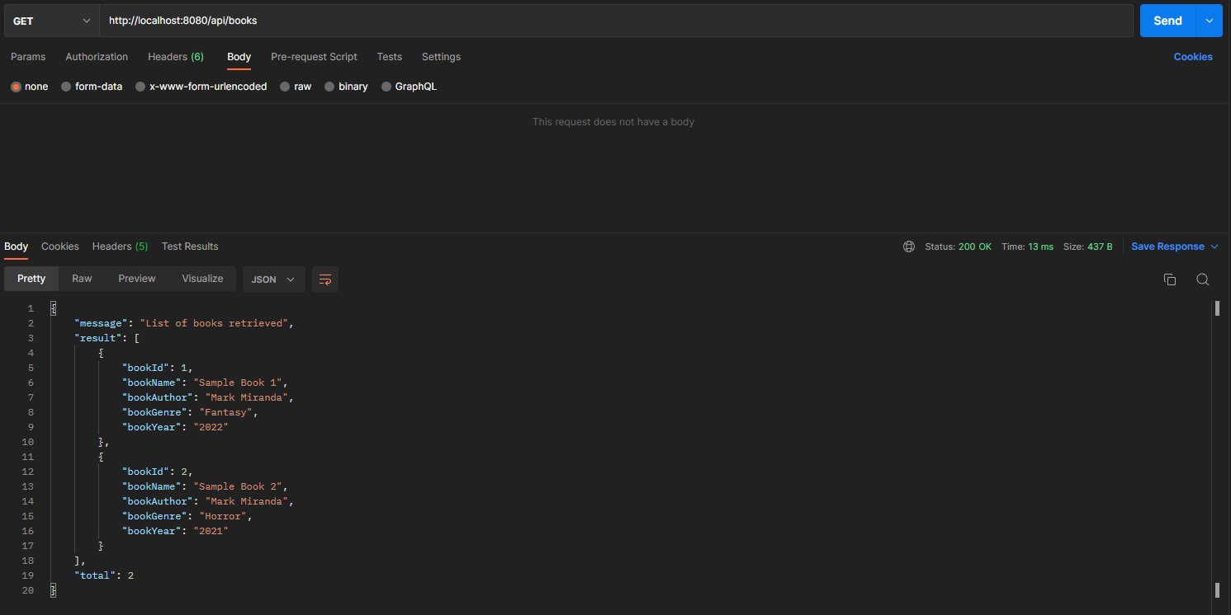

Retrieving a specific Book: **/books/{bookId}**

Using GET method: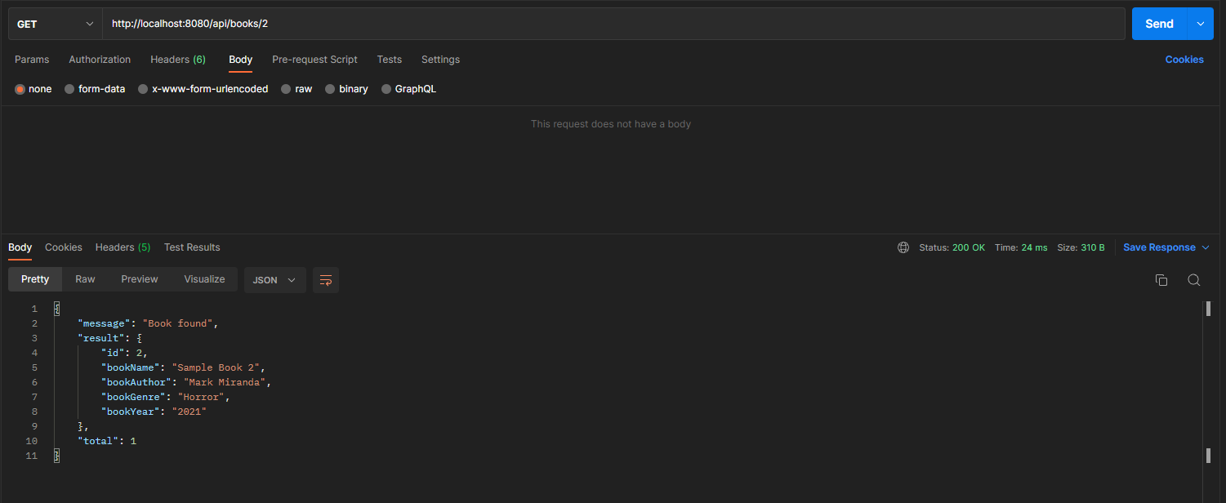

Deleting a specific Book: **/books/{bookId}**

Using DELETE method:

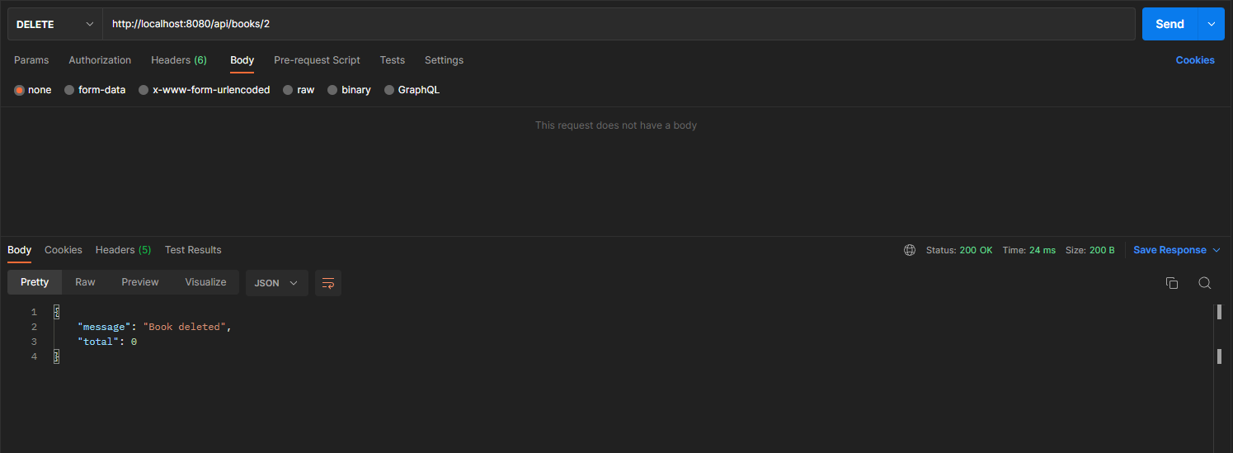

Updating a specific Book: /books

Use PUT method:

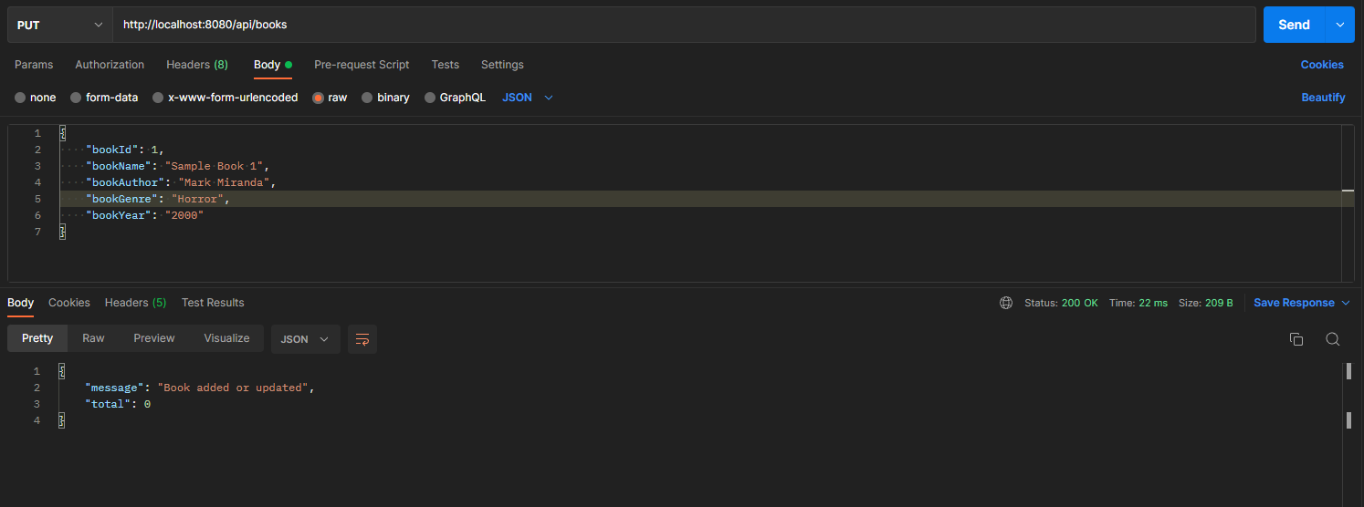

Before:

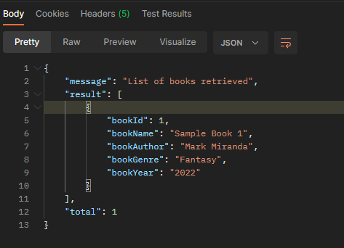

After:

